Screenshots or program listings must be copied into appropriate cells in the following table.
Save this evidence document as evidence_ followed by your centre number_ candidate number, for example, evidence_ zz999_9999 and insert your name, candidate number and centre number into the header above.
Examiners must be able to read the contents including any screenshots without the use of a magnifying glass. Answers that are not readable or are missing will not be awarded any marks.
Save this evidence document at regular intervals, for example every 10 minutes.
Question 1
Part 1(a)(i)
global StackVowel, StackConsonant
StackVowel = [''] * 100 #array of char
StackConsonant = [''] * 100 #array of char

Part 1(a)(ii)
global VowelTop
VowelTop = 0 #integer
global ConsonantTop
ConsonantTop = 0 #integer

Part 1(b)(i)
def PushData(x):
global StackVowel, StackConsonant, VowelTop, ConsonantTop
if x in ['a', 'e', 'i', 'o', 'u']:
if VowelTop == 99:
print("Stack vowel is full")
else:
StackVowel[VowelTop] = x
VowelTop += 1
else:
if ConsonantTop == 99:
print("Stack consonant is full")
else:
StackConsonant[ConsonantTop] = x
ConsonantTop += 1

Part 1(b)(ii)
def ReadData():
with open("StackData.txt", encoding = 'utf-8') as f:
for line in f:
PushData(line.strip())

Part 1(c)
def PopVowel():
global StackVowel, VowelTop
if VowelTop == 0:
return "No data"
else:
VowelTop -= 1
tmp = StackVowel[VowelTop]
StackVowel[VowelTop] = ''
return tmp

def PopConsonant():
global StackConsonant, ConsonantTop
if ConsonantTop == 0:
return "No data"
else:
ConsonantTop -= 1
tmp = StackConsonant[ConsonantTop]
StackConsonant[ConsonantTop] = ''
return tmp

Part 1(d)(i)
def main():
ReadData()
cnt = 0
res = ""
while cnt < 5:
a = input("Enter either vowel or consonant: ")
if a.lower() == 'vowel':
tmp = PopVowel()
else:
tmp = PopConsonant()
if tmp != "No data":
res += tmp
cnt += 1
else:
print(f"The {a.lower()} stack is empty, choose the other one.")
print(res)

if __name__ == "__main__":
main()

Part 1(d)(ii)
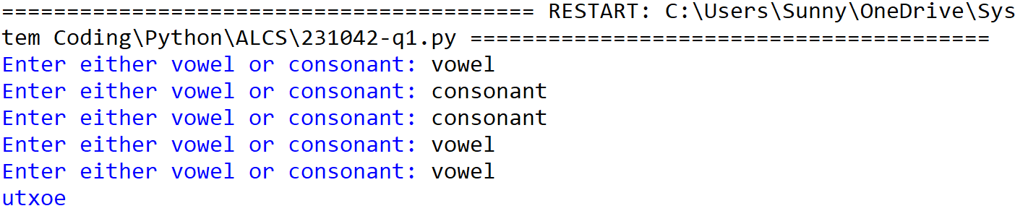

Question 2
Part 2(a)(i)
def IterativeCalculate(Number):
ToFind = Number
Total = 0
while Number != 0:
if ToFind % Number == 0:
Total += Number
Number -= 1
return Total

Part 2(a)(ii)
def main():
print(IterativeCalculate(10))

if __name__ == "__main__":
main()

Part 2(a)(iii)

Part 2(b)(i)
def RecursiveValue(Number, ToFind):
if Number == 0:
return 0
else:
if ToFind % Number == 0:
return Number + RecursiveValue(Number - 1, ToFind)
else:
return RecursiveValue(Number - 1, ToFind)

Part 2(b)(ii)
def main():
print(RecursiveValue(50, 50))

if __name__ == "__main__":
main()

Part 2(b)(iii)

Question 3
Part 3(a)(i)
from datetime import date
class Character:
def __init__(self, name, date, iq, speed):
self.CharacterName = name #string
self.DateOfBirth = date #date
self.Intelligence = iq #float
self.Speed = speed #integer

Part 3(a)(ii)
def GetIntelligence(self):
return self.Intelligence
def GetName(self):
return self.CharacterName

Part 3(a)(iii)
def SetIntelligence(self, x):
self.Intelligence = x

Part 3(a)(iv)
def Learn(self):
self.Intelligence *= 1.1

Part 3(a)(v)
def ReturnAge(self):
return 2023 - self.DateOfBirth.year

Part 3(b)(i)
def main():
FirstCharacter = Character("Royal", date(2019, 1, 1), 70.0, 30)

if __name__ == “__main__”:
main()

Part 3(b)(ii)
def main():
FirstCharacter = Character("Royal", date(2019, 1, 1), 70.0, 30)
FirstCharacter.Learn()
print(f"Name: {FirstCharacter.GetName()}\nAge: {FirstCharacter.ReturnAge()}\nIntelligence: {FirstCharacter.GetIntelligence()}")

if __name__ == "__main__":
main()

Part 3(b)(iii)
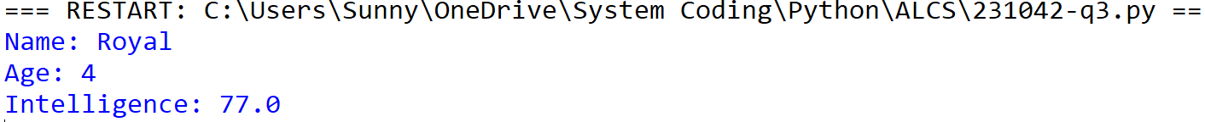

Part 3(c)(i)
class MagicCharacter(Character):
def __init__(self, name, date, iq, speed, element):
Character.__init__(self, name, date, iq, speed)
self.__Element = element

Part 3(c)(ii)
def Learn(self):
if self.__Element.lower() in ['fire', 'water']:
self.Intelligence *= 1.2
elif self.__Element.lower() == 'earth':
self.Intelligence *= 1.3
else:
self.Intelligence *= 1.1

Part 3(d)(i)
FirstMagic = MagicCharacter("Light", date(2018, 3, 3), 75.0, 22, 'fire')

Part 3(d)(ii)
def main():
FirstCharacter = Character("Royal", date(2019, 1, 1), 70.0, 30)
FirstCharacter.Learn()
print(f"Name: {FirstCharacter.GetName()}\nAge: {FirstCharacter.ReturnAge()}\nIntelligence: {FirstCharacter.GetIntelligence()}")
FirstMagic = MagicCharacter("Light", date(2018, 3, 3), 75.0, 22, 'fire')
FirstMagic.Learn()
print(f"Name: {FirstMagic.GetName()}\nAge: {FirstMagic.ReturnAge()}\nIntelligence: {FirstMagic.GetIntelligence()}")

if __name__ == "__main__":
main()

Part 3(d)(iii)
